**Database and file Management Systems** (CIS 2109)

**Homework 04**

1. Answer the following questions from your book:

**Chapter 4**

4.58

**Problem 01**

You are given the following data describing data regarding authors, books, and publishers. In addition, the data tells us what an individual author’s per book royalty amount is in the case of multiauthored books.

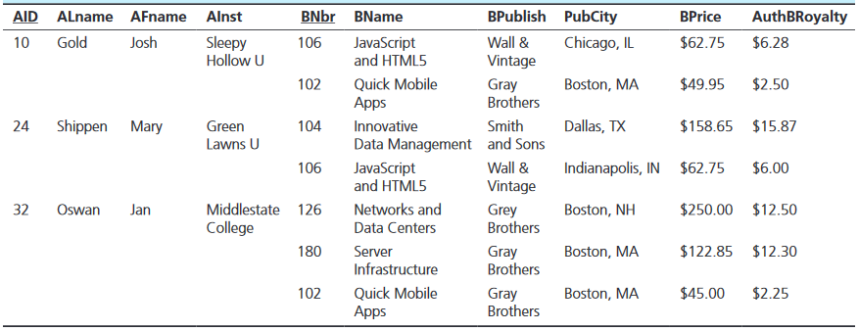

Now, answer these questions:

1. What is the normal form of the data?
2. Is this a relation?
3. Do you see any possible anomalies?
4. Identify the errors in the data that have been made possible by its poor structural characteristics
5. Identify the functional dependencies between the attributes - Assume that the primary key of this relation consists of two components: Author’s ID (AID) and Book number (BNbr)
6. Take the actions (if any) necessary to convert the data into the third normal form. Identify all intermediate steps.

**Problem 02**

You are given a dataset with the following attributes:

ComputerID, VendorID, VendorName, VendorPhone, VendorSupportID, VendorSupportName, VendorSupportExtension, SoftwareID, SoftwareName, SoftwareVendor, SoftwareExpdate, SoftwarePrice, UserID, UserName, UserAuthDateStarts, UserAuthDateEnds, UserAuthPass, PurchasePrice

And the following business rules:

* The data includes information about individual computers, their vendors, software packages running on the computers, computer users, and user authorizations.
* Users are authorized to use a specific software package on a specific computer during a specific time frame (characterized with attributes UserAuthDate Starts and UserAuthDateEnds and secured with a password UserAuthPass).
* Software is licensed to be used on specific computers (potentially multiple software packages at the same time) until an expiration time (SoftwareExpDate) at a specific price (SoftwarePrice)
* Computers are sold by vendors, and each vendor has a support person with an ID, name, and phone extension.
* Each individual computer has a specific purchase price.

Based on this information:

1. Identify the functional dependencies between the attributes.
2. For every functional dependency characterize it as Full, Partial or Transitive
3. Is this relation in 3NF? Why?
4. If needed present the attributes organized so that the resulting relations are in 3NF.

**Problem 03**

You are given the following data describing a bus company and the Route schedules.



Notice that there may be multiple scheduled buses for every route, the certification is specific to a particular vehicle and driver pair and has a specific duration (marked by DCStartDate and DCSendDate). Now:

1. Identify the functional dependencies between the attributes
2. What is the normal form (if any) of the data?
3. Including all intermediate stages, organize the attributes into a set of 3NF relations
4. Draw an ER diagram based on the normalized relations